 | Chargeback Calculation  Technical Design Document  1.0
 | Prepared By / Last Updated By | Reviewed By | Approved By
Name | Prabhakar Yadav | Sarthak Shukla | Person 3
Role | Team Member | Team Member | Scrum Master
Signature
Date

Table of Contents

1.0 Introduction 3
1.1 Purpose of this document 3
1.2 Scope 3
1.3 Intended Audience 3
1.4 Definition & Acronyms 3
2.0 Conventions and Standards Followed 4
3.0 Assumptions, Dependencies and Risks 4
3.1 Assumptions: 4
3.2 Dependencies: 4
4.0 Schematic Diagram 4
5.0 Use Case Realization 5
5.1.1 User Registration 5
a. Functional Requirement 6
b. UI Validations 6
c. UI Controls 7
d. UI Methods Definition 8
e. UI Design 9
6.0 Database Design 10
6.1 Data Model 10
6.2 Tables Structure 10
7.0 Change Log 13

Introduction

Purpose of this document
The purpose of the detail design document is to define the detailed design for all the components of ChargeBack Calculation are specified in the Business Requirement/Use case document. All the low level components, interfaces and integrations are detailed out in this document.

Scope
This sub-section shall state the scope of this detailed design document
• Create and maintain Admin information.

Intended Audience
The intended audience for this document are
- Developers, testers, other associates in the project
- Technical lead, Scrum Master
- Product Owner

Conventions and Standards Followed
The modules under scope needs to adhere to the coding standards and guidelines


Assumptions, Dependencies and Risks

Assumptions:
- Once the application is built the CHARGEBACK CALULATION PORTAL will manually load the Customers list into the system.
- Transaction Table is present in database which contains every transaction Details of each user.
- Any changes to the design mentioned in the BRD would be taken as a Change Request

Dependencies:
- Availability of database design characteristics & access shall be defined by the
- Resource availability throughout each of the sprint

Schematic Diagram
A schematic, or schematic diagram, is a representation of the elements of a system using abstract, graphic symbols rather than realistic pictures. It gives an overview of overall system
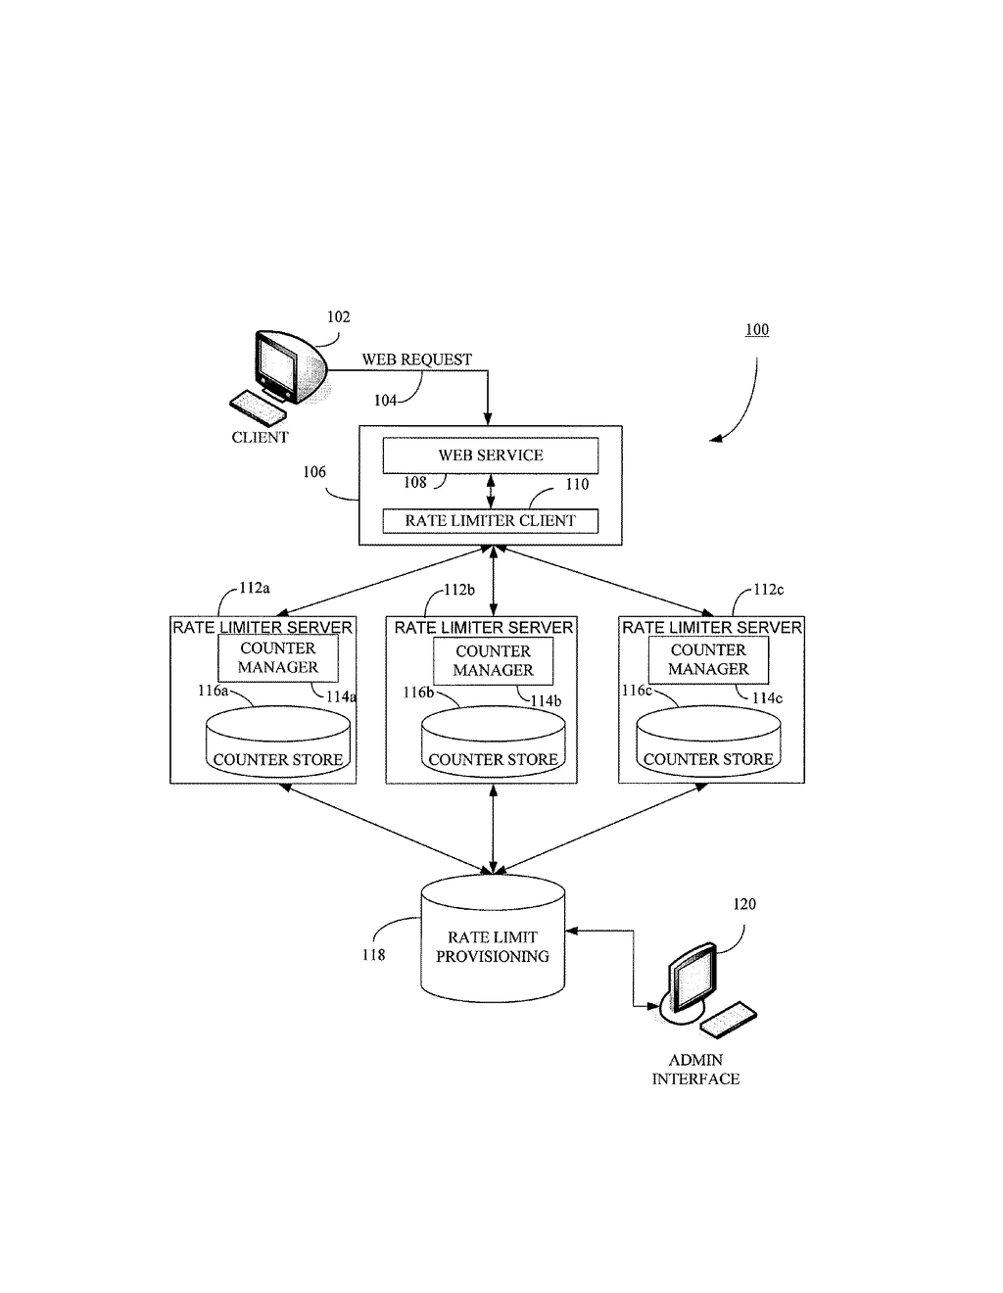
The above pic is only an example and not representational of the ChargeBack Calculation.

Use Case Realization

User Registration

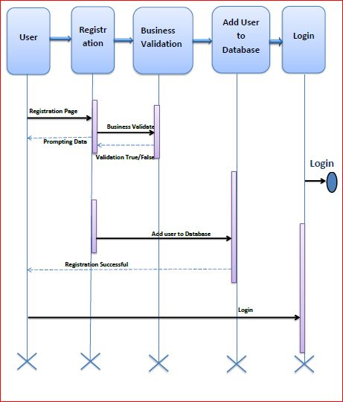

Functional Requirement
. Login Page checks the authentication of the Bank Representative user and based on his role, directs the Bank Representative user to the respective page. Bank Representative User will provided with , List of all Customers and if customer clicks the ChargeBack Details button then it will show list of all customers who requested for the refund in next page and can give refund or reject the request.
- User Id and Password fields are mandatory.
- Invalid User Id and / or password should not allow the user to get into the system

UI Controls
# | UI Component | Type | Name | Details
1 | User | Text field | username | To enter username
2 | Password | Text field | password | To enter password

UI Methods Definition

Method Name | Parameter | Details
Login_Click | Username, Password | Allows the user to login into the portal .
Create_Your_Account_Click | Null | Loads the Registration Page.
SignUp_Click | Username,password, object-Model | Allows the user to store the information into Database.
ViewButton_Click | id,object-model,principal | Loads the transaction page to List all the transaction details of user.
ADDButton_Click | Id,object-Model,principal | Loads the AddPayment page to modify the Details.
ChargeBack_Details_Click | Object-Model,Principal | Loads the ChargeBack details page to show all the user how requested for the refund.
EditButton_Click | Object-Model,principal | Loads the edit page to modify the chargeback details
RefundButton_Click | object Model,principal | Loads the refund page to modify the refund details
UpdateButton_Click | Object Model,principal | Update the refund details in the database.

UI Design
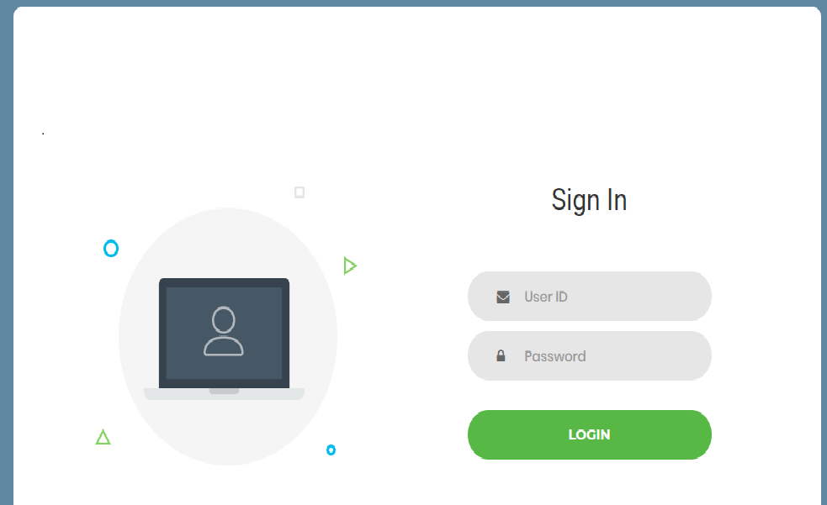

Database Design

Data Model

The following is a schematic view of the database design
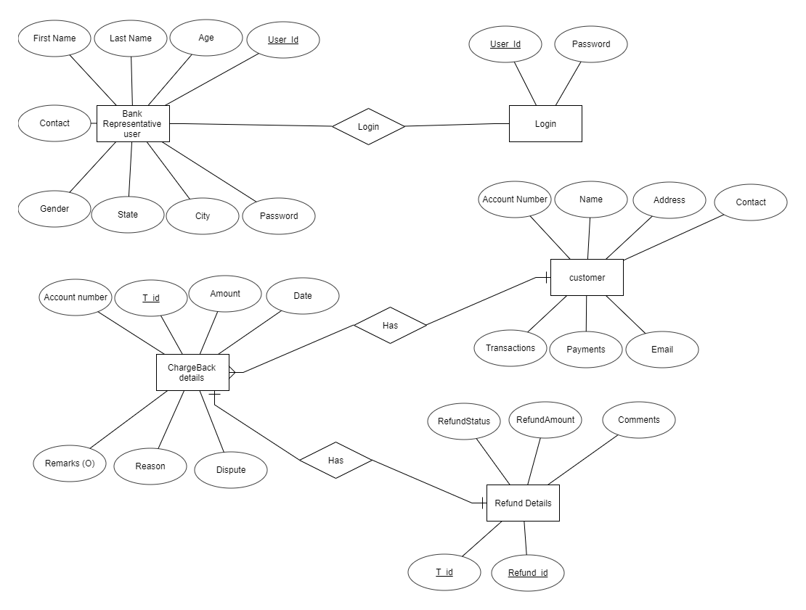

Tables Structure
Bank Representative User Registration:
Column Name | Data Type | Length | Nulls
User Id | nvarchar | 50 | N
Password | nvarchar | 50 | N
First Name | nvarchar | 50 | N
Last Name | nvarchar | 50 | N
Age | int | 5 | N
Gender | varchar | 10 | N
Contact | varchar | 10 | N
City | nvarchar | 50 | N
State | nvarchar | 50 | N

User login:
Column Name | Data Type | Length | Nulls
User Id | nvarchar | 50 | N
Password | nvarchar | 50 | N

Customer Details:
Column Name | Data Type | Length | Nulls
Account Number | varchar | 10 | N
Address | nvarchar | 50 | N
Contact | nvarchar | 50 | N
Name | date |  | N
Email Address | nvarchar | 50 | Y

Chargeback Details:
Column Name | Data Type | Length | Nulls
Account Number | bigint | 20 | N
t_id | bigint | 20 | N
Amount | float |  | N
Date | date |  | N
Dispute | nvarchar | 11 | N
Reason | nvarchar | 255 | N
Remarks | nvarchar | 255 | N

Refund Details:
Column Name | Data Type | Length | Nulls
Refund_id | bigint | 20 | N
comments | nvarchar | 255 | N
refundAmount | float |  | N
refundStatus | int | 11 | N
t_id | Bigint | 20 | N

Change Log
Please note that this table needs to be maintained even if a Configuration Management tool is used.
Version Number | Changes made
V1.0 | <First version>
V1.1 | <If the change details are not explicitly documented in the table below, reference should be provided here>
V1.1 | Page no | Changed by | Effective date | Changes effected
V1.2 | <If the change details are not explicitly documented in the table below, reference should be provided here>
V1.2 | Page no | Changed by | Effective date | Changes effected

